**THE CHURCH OF SAINT ANDREW,**

**APOSTLE & MARTYR**

[**www.standrewstac.com**](http://www.standrewstac.com)

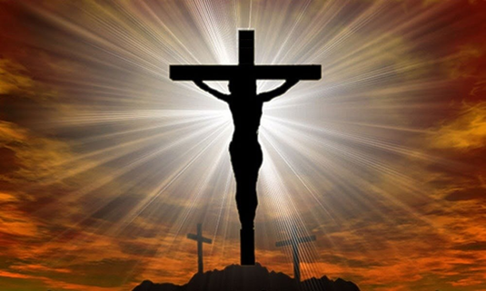

**LENTEN THEME 2025**

In the New Testament, the phrase ***the mind of Christ*** appears in 1 Corinthians 2:16 and Philippians 2:5-8.  It refers to the perspective, purpose, and plan of Christ, which believers share:

***Let each of you look not only to his own interests, but also to the interests of others.***

***5Have this mind among yourselves, which is yours in Christ Jesus, 6who, though he was in the form of God, did not count equality with God a thing to be grasped,***

***7but emptied himself, by taking the form of a servant, being born in the likeness of men.***

***8And being found in human form, he humbled himself by becoming obedient to the point of death, even death on a cross.***

**L E N T 2 0 2 5**

Lent is approximately forty days long, if you count the days from Ash Wednesday to Holy Thursday’s Evening Eucharist of the Lord’s Supper.

Lent is a period of preparation to celebrate the Lord's Resurrection at Easter. During Lent, we seek to draw closer to the Lord in prayer by practising greater self-discipline and abstaining from luxuries to help

us follow Christ more faithfully.

|  |  |
| --- | --- |
| **MARCH 5**  Ash Wednesday | **Ash Wednesday** begins the Lenten season. **The imposition of ashes** will take place at 10:00 at the Eucharist and at 18:00 via the “drive by” method we started during the Covid pandemic. |
| **MARCH 2**  Shrove ‘Sunday’ | The preceding Sunday will include traditional pancakes in Founders Hall after Mass. R5 per pancake. |
| **APRIL 13**  Holy Week | **Holy Week** begins with the commemoration of Christ's triumphal entry into Jerusalem on **Palm Sunday.** |
| **APRIL 16**  Quiet morning | **Quiet morning** at the church from 10am to 2pm. |
| **APRIL 17**  Maundy Thursday | **Maundy Thursday** Evening Eucharist of the Lord’s Supper |
| **APRIL 18**  Good Friday | **Holy Week** climaxes with the Passion of Jesus. Service at 12 noon |
| **APRIL 20**  Easter Sunday | **Easter Sunday** always occurs on the first Sunday after the  Paschal Full Moon, which is the first Sunday following the full Moon that occurs on or after the S[pring Equinox](https://www.almanac.com/content/first-day-spring-vernal-equinox). |

